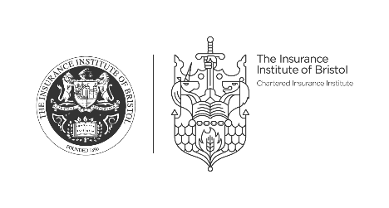

127th Annual Dinner
The Marriott Bristol City Centre Hotel
Friday 27th April 2018

Starter

Goats Cheese, heritage beetroot, basil salad

Main Course

Chicken Supreme
Served with roast potato with thyme & salt and
carrots with honey, butter and parsley

or

Tagliatelle (v)*
with pecorino, sun-blushed tomato and basil

Dessert

Vanilla Panna Cotta with
strawberries, basil and shortcake

Cheese Platter

West Country Cheeseboard

*****

Filter coffee
with mints

* Please note that the vegetarian option is only available if pre-ordered

