CNA Hardy Emerging trends in the marine market

Presented by: Neil Atkinson

September 28, 2016

Contents 2

About
CNA Hardy

Cyber What are the marine exposures

SOLAS VGM
Update Clandestine entry
The
Insurance
Act
Flood

Relying on the carrier

Hanjin What does it mean for cargo/T&L

About CNA Hardy

Neil Atkinson
Regional Marine Underwriting Manager
+44 161 242 4423
neil.atkinson@cnahardy.com

CNA Hardy - Company overview 5

Property Casualty Marine Specialty

Our Industry Specialisms:

Construction Energy Financial Institutions Healthcare

Manufacturing Professional Services Technology & Cyber Transport & Logistics

Cyber

---------------------------------CNA / HARDY

• Data leakage

• Piracy

• Recent studies on potential effects for marine market

• Problems with power supply – cold stores

• Cyber exclusion

• Problems with the Cyber Exclusion Clause

• “…in no case shall this insurance cover loss damage liability or expense directly or indirectly caused by …. the use or operation, as a means for inflicting harm, of any computer, computer system, computer software programme, malicious code, computer virus or
process or any other electronic system....”

• Cyber Clause – re-write

• Proximate cause?

SOLAS VGM

• What is VGM?

• Why is it needed

• Came into effect 1st July 2016

• 3 months for ports to become compliant

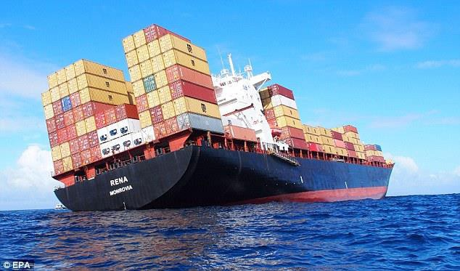

• Who is responsible?

• UK ports – new weigh bridges

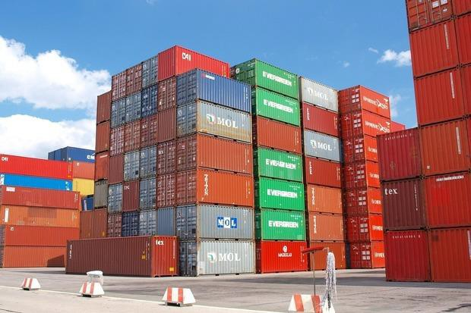• Overseas ports

• Problems

Clandestine Entry

• Problems in Calais

• Complicit officials?

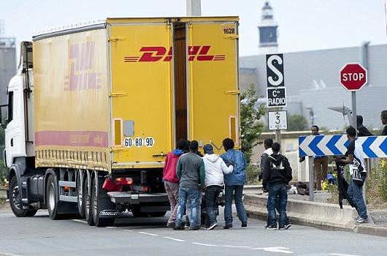• Increased use of

violence

• Striking French lorry drivers

• Driver fines

• Port strikes

• Other issues –

organised crime

• Use of warranties

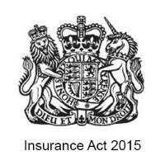– Towage/Sub-Sea market

• Occasional „data dumping‟

• Use of subjectivities – warehouse surveys

• Commerciality of marine market

Flood

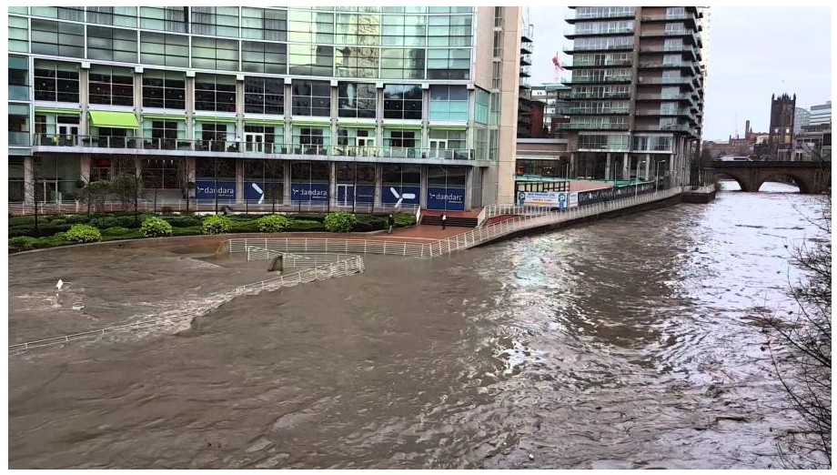

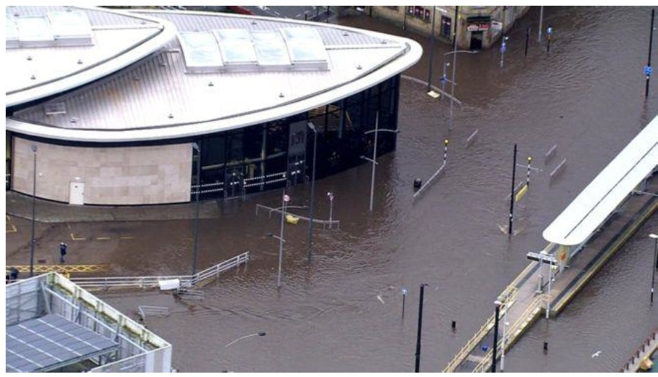

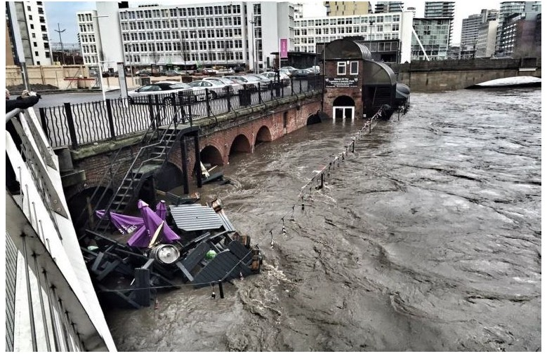---------------------------------- CNA / HARDY

• Marine insurers – flood checking

• Marine Insurer v Stock Insurer!

• 2015 floods – a wake up call

• Environment Agency web-site

• Cat modelling

• Knee-jerk responses

Relying on the carrier

• Increased reliance on carriers

• Uplifted conditions

• Push for “All Risks” / Full Responsibility

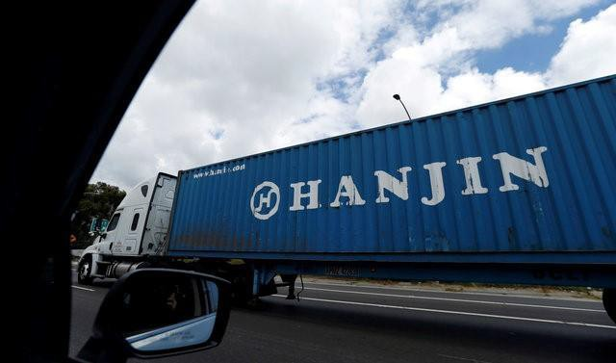• What is actually covered?

• Warehousing Full Responsibility

• Customer Storage Insurance

• Increase in bespoke contracts

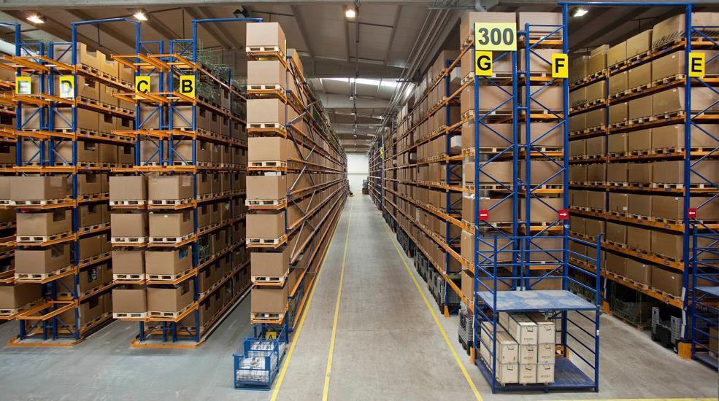• KPI‟s and contract penalties

• Contracts – force majeure?

Hanjin – problems with bankruptcy

• Hanjin – 7th largest container carrier

• 3.7 million TEU‟s annually

• 3.0% of total container capacity

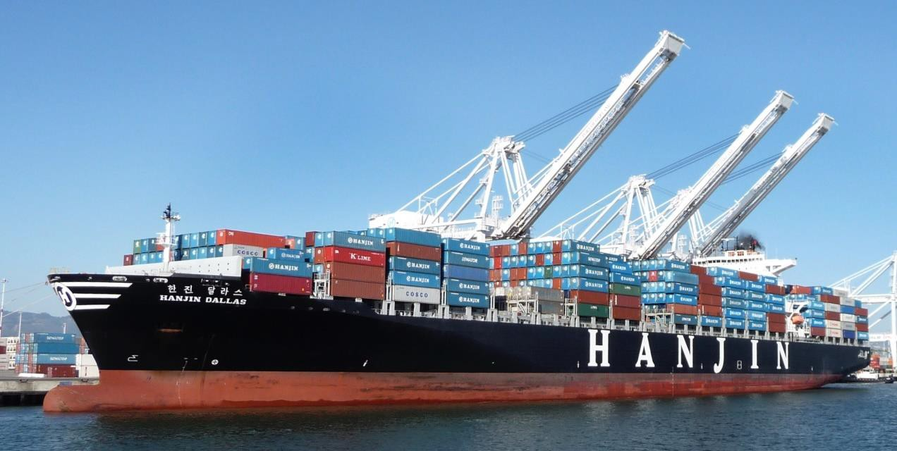• Debt of $5.5bn

• Mostly FE/US

• Will it be the last?

• What does it mean for cargo owners?

– Check contract with the Freight Forwarder

– Additional Forwarding Costs

– Leased containers?

– Perishable goods

– Delay – proximate cause

• What does it mean for T&L?

– Additional costs incurred – recoverable?

– General exclusion for insolvency

Neil Atkinson
Marine Underwriting Manager
+44 161 242 4423 neil.atkinson@cnahardy.com

The information contained in this presentation does not represent a complete analysis of the topics presented and is provided for information purposes only. It is not intended as legal advice and no responsibility can be accepted by CNA Hardy for any reliance placed upon it. No representation or warranty, express or implied, is made as to the contents of this presentation, or for the omission of any material from this presentation. Legal advice should always be obtained before applying any information to particular circumstances.

Please remember that only the relevant insurance policy can provide the actual terms, coverages, amounts, conditions and exclusions for an insured. All products may not be available in all countries.

29

When it comes to business insurance…
We can show you more®

CNA Insurance Company Limited (registered number 950) CNA Switchboard: +44 (0)20 7743 6800 Facsimile: +44 (0)20 7743 6801 Authorised by the Prudential Regulation Authority and regulated by the Financial Conduct Authority and the Prudential Regulation Authority (number 202777) Hardy (Underwriting Agencies) Limited (registered number 1264271) Hardy Switchboard: +44 (0)20 7105 0382 Facsimile: +44 (0)20 7327 3615 Authorised by the Prudential Regulation Authority and regulated by the Financial Conduct Authority and the Prudential Regulation Authority (number 204843) CNA Services (UK) Limited (registered number 8836589) CNA Switchboard: +44 (0)20 7743 6800 Facsimile: +44 (0)20 7743 6801
The above companies are all registered in England with their registered office at 20 Fenchurch Street, London, EC3M 3BY. VAT registration number 667557779.

