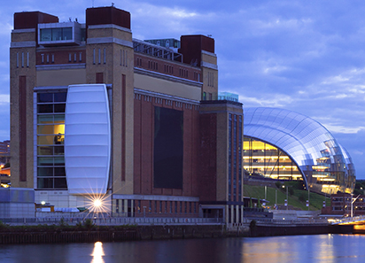

**The Insurance Institute of Newcastle-upon-Tyne**

**Annual Report for the year 2015 - 2016**

Contents

AGM Programme 3

General Information 3

AGM Notice 4

Local Institute Council and Officers 2015-2016 5

President’s Annual Review 6

Secretary’s Report 7

Education Secretary’s Report 8

Dinner Secretary’s Report 9

Public Relations Secretary’s Report 10

Charities Representative’s Report 11

Personal Finance Society Representative’s Report 12

Council Proposed Deputy President 2016-2017 13

Treasurer’s Report 14

Financial Statements for the year ended 31st December 2016 16

General Information 17

Trading Profit and Loss Account 18

Balance Sheet 19

# AGM Programme

1. Apologies for absence

2. Approval of the minutes of the AGM held April 2015

3. Matters arising from the minutes

4. President’s Report

5. Treasurer’s Report

6. Secretary’s Report

7. Questions from the floor

8. Election of Officers

9. Handing over Chairs of Office (Presentation of Badges)

10. New President’s Address

11. Any Other Business

# General Information

Insurance Institute of Newcastle upon Tyne

c/o Tesco Underwriting

Quorum Business Park,

Newcastle upon Tyne,

NE12 8BU

**E-mail**: [newcastleinsinst@gmail.com](mailto:newcastleinsinst@gmail.com)

**Website**: [www.cii.co.uk/newcastle](http://www.cii.co.uk/newcastle)

**AGM**: Thursday 21st April 2016

**Venue:** Tesco Underwriting, Quorum Business Park, Newcastle upon Tyne, NE12 8BU.

**President**: Brian Stonehouse BA, Assoc CIPD – Eldon Insurance

**Deputy President:** Katy Thorne BA (Hons), FPFS – Gale & Philipson

Cover photograph courtesy of Alan Green, of H&H Insurance Brokers

# AGM Notice

119th Annual General Meeting of the Insurance Institute of Newcastle upon Tyne 2016

This year’s Annual General Meeting (AGM) will be held at **Tesco Underwriting, Quorum Business Park, Newcastle upon Tyne, NE12 8BU** on **Thursday 21st April 2016** at **17:00 (for 17:30).**

All Council nominations are listed below and will be approved at the AGM.

Please contact the Secretary 14 days prior to the AGM if you would like to make an objection to any of the points or to request a copy of the 2015 minutes.

The existing Council recommends that members vote in favour of all the resolutions being proposed at the AGM, which they consider to be in the best interests of the institute as a whole.

**NOTICE** is hereby given that the AGM of the Insurance Institute of Newcastle upon Tyne will be held at **Tesco Underwriting, Quorum Business Park, Newcastle upon Tyne, NE12 8BU** at **17:00** – for the following purposes:

**1.** The proposed President of the Institute for 2016/17 is Katy Thorne of Gale & Philipson.

**2.** The proposed Deputy President of the Institute for 2016/17 is Julie Hyde of Arista Insurance.

**3.** To receive and adopt the Treasurer’s Report and Accounts for 2015

**4.** To receive and adopt the Annual Report of Council for 2015/16

**5.** To elect the following Vice-Presidents for the session 2016/17; **Under rule 12a)**: Richard Talbot-Jones, Jill Carter, Brian Stonehouse, Katy Thorne; **Under rule 12b)**: None

**6.** To elect the following ex-officio members of the Council for the session 2016/17

**Secretary:** Dawn Lowery – Tesco Underwriting

**Treasurer:** Willard Wright – Walter Wright Insurance Brokers

**Education Secretary:** Ian Stockley – Tesco Underwriting

**Examinations Secretary:** Vincent O’Sullivan

**Sports & Social Secretary**: Peter Locker – Chubb Insurance

**Public Relations Secretary:** Kate Allison – Insure Business Ltd

**Dinner Secretary:** David Holder – Cunningham Lindsay

**7.** To elect the following Council members for the session 2016/17

John Bruce, Rachel Bruce, David Hall, Matthew Hodgson, Helen Johnson, Tim McGee, David Nield, David Gunning

**8.** To appoint Glen C Rodger Ltd Accountants for the session 2016/17.

**9.** Appoint a Charities Representative: David Robson - Markel

# Local Institute Council and Officers 2015-2016

**President**: Brian Stonehouse BA, Assoc CIPD

**Deputy President**: Katy Thorne BA (Hons), FPFS

**Vice Presidents 12a**: Jill Carter ACII;

John Bruce Certs CII (MP & ER), Dip PFS, FCSI;

Richard Talbot-Jones BA (Hons), PgDip, ACII

**Secretary**: Dawn Lowery Cert CII

**Treasurer:** Willard Wright BA (Hons), ACII

**Education Secretary**: Ian Stockley Cert CII (Claims)

**Dinner Secretary**: David Holder

**Sports and Social Secretary:** Peter Locker ACII

**Public Relations Secretary**: John Neill BSc (Hons), MBA, FCII, FCMI

**Examinations Secretary**: Vincent O’Sullivan ACII

**Other Officers**: Kate Allison MBA, ACII

Peter Blacklock Dip PFS

Matt Hodgson ACII

Julie Hyde ACII

Tim McGee ACII, ACILA

Robert McGregor MBA, ACII

David Nield BA (Hons), ACII

**PFS Representative**: David Gunning Certs CII (MP&ER), Dip PFS

**Charities Representative**: David Robson Cert CII

# President’s Annual Review

The function of the President is to:

* Represent the local institute at local, regional and national events
* Maintain the profile of the local institute locally, regionally and nationally in a professional manner taking due cognisance of the demands of a continually changing industry/membership
* Develop and expand the services of the local institute for the benefit of all members across all disciplines both for the individual academic development and personal skills/social development, liaise with other appropriate professional bodies in the area
* With the Treasurer ensure the local institute is run on a financially sound basis

2015/16 has been a thoroughly enjoyable year for me as president. It has flown by, and I immensely proud of the support and commitment I have received from my fellow council members.

Each year the incoming President chooses a theme for their year in office and I decided to focus on **‘Developing’**. My predecessor Jill Carter and the presidents before her set a great platform for me to build on. The aims I set the council for 2016 were:

**Developing our Membership Network:**

This year we focused on developing our current relationships with local businesses, as well as forging new relationships to enhance our growing network. We achieved this in part through our YPG members attending a University careers event at Newcastle University in July 2015. This was supported by Rachel Bruce delivering a council message at the Q4 PFS conference which was also attended by Katy Thorne our Deputy President, John Bruce one of our Vice Presidents, as well as myself.

**Developing our Council:**

Last year saw the council introduce a Young Professional Subcommittee which started off very well. They have made some further progress and will look to kick on following this year's AGM. We have also welcomed some new council members, by way of Kate Alison, Robert McGregor and our past president Matt Hodgson.

**Developing our Educational Programme:**

Our Education Programme of 2014/15 was a great success. However, 2015/16 has been even better. This is testament to the fantastic efforts of our Education Secretary; Ian Stockley. He has put on an excellent and varied CPD programme to cater for all of our members. This has been supported by the efforts of Dave Gunning one of our PFS members, who successfully organised and facilitated an RO8 study session for our PFS members. So much so that we had requests for further sessions.

The other highlights of the year for me have been:

* **Annual Dinner** – Through the hard work of David Holder and Julie Harle this was well organised and well attended.
* **Charity** – Due to the generosity of our members at our annual dinner, we have been able to donate £1250 to both the Insurance Charities and my chosen charity, the Royal British Legion.
* **CII Service Awards** – Our very own John Bruce won a Service award from CII London

I would like to take this opportunity to thank my colleagues on council for their continued efforts in maintaining the high standard which is associated with the Insurance Institute of Newcastle upon Tyne. I would also like to wish Katy Thorne every success for the ensuing year as our President.

Brian Stonehouse BA, Assoc CIPD

President

# Secretary’s Report

During the course of the year 7 Council meetings have been held with an average attendance of 10.71 Council members, an increase from 10.33 in 2014/2015. Total membership is 21.

The function of the Secretary is to:

* Keep or cause to be kept proper minutes or reports of all meetings of the institute and the Council, summon all meetings
* Maintain a register of the names and addresses and such other records of the members of the institute as the Council may determine
* Ensure that the local institute conducts its affairs at all times in compliance with its constitution
* Ensure that the local institute’s constitution conforms to the CII’s Charter and Bye-laws and that it is kept up to date
* Report to Council on any non-conformity with the constitution
* Ensure that all meetings of Council and committees are correctly called and are quorate
* Supervise the election of members of Council
* Ensure that returns required by the CII are correctly compiled and submitted on time
* Act as Returning Officer for the local institute whenever elections are held for the post of CII Regional Council Representatives
* Normally be undertaken for a term of one year although the constitution of the local institute allows for a longer period.

19% of Council members are also members of the PFS.

Our first meeting of 2015/2016 was held at Landmark Chinese Restaurant in the centre of Newcastle and all subsequent meetings have been held in the Tescobank building at Quorum Business Park, where Tescobank/Tesco Underwriting generously allow us access to meeting facilities free of charge.

In December we had a visit from Helen Johnson, Education Secretary for the PFS who gave us a short presentation on her plans for events for PFS members and how some could link in with CII. Sandra McDonald joined us at our AGM and again at our meeting in March 2016

There has been some change in the membership of Council during the year, as we were delighted to welcome Robert McGregor as a Council member and to welcome back Matt Hodgson on his return from Manchester. Connor Monson took up position as Chair of the Young Professionals Group, and as a consequence, also joined Council. I had great pleasure in taking up the position of secretary.

The annual returns to the CII, most of which were due by 31 May 2015, were all submitted well in advance of the deadline.

Based on figures available at 4 March 2016, total membership numbers for the Insurance Institute of Newcastle Upon Tyne has increased slightly over the period March 2015 to 1668 which includes 853 PFS members

**MEMBERSHIP March 2016**

Ordinary 1130

Cert CII/PFS 233

Dip CII/PFS 48

ACII/APFS 212

FCII/FPFS 38

Senior 7

Total 1668 of which 233 are Chartered

Dawn Lowery Cert CII

Secretary

# Education Secretary’s Report

**CPD**

The function of the Education Secretary is to:

* Co-ordinate the educational work of the institute in such manner as the Council may determine
* Act as agent for the proper administration and carrying out of the CII’s examinations according to the regulations prescribed by the CII
* Give such assistance as may be prescribed in regard to the CII’s tuition schemes
* Advise potential new members on the range of qualifications open to them
* Advise existing students on options as regards to future examinations
* Advise qualified members on further qualifications by the CII that could benefit them
* Act as the focal point for those seeking advice on all educational aspects relating to the CII Examinations
* Advise qualified members on CPD requirements and ways to maintain their CPD (or to direct such members to the appropriate person within the local institute)
* Arrange for the provision of local examination centres
* Identify local prize-winners.

We have delivered a total of **12** training/lunch time sessions for our members throughout the year. These have been spread across industry technical training as well as soft skills and compliance. In excess of **236** members attended the Lunch & Learn Sessions:

* 2x Linkedin sessions
* 2x Fraud sessions
* Casualty Fraud
* Bank of England session
* FOS introduction session
* FCA Masterclass with Branko
* Reducing the cost of errors
* Making clients feel like stars
* Flood & Wet perils
* Donoghue v Stevenson – What the text books don’t tell you

We are also required to offer examination revision support, but have been unable to complete this.

We have also offered support through the CII’s Young Professional Group who attended a careers day at Newcastle University to increase awareness of opportunities in the Insurance industry.

**CPD Support and Advice**

We have supported CPD promotion through the local institute LinkedIn page as well as our e-flyer system to promote our own locally run events through the Council as well as those through CII Broker Academy both here in Newcastle as well as Leeds. After each CPD event ran through the local institute we have offered CPD queries support, always utilising the assistance of our CII contact.

**Examination Support and Advice**

Our Exams Secretary, Vincent O’Sullivan, has once again done a fantastic job in arranging the venue, ensuring that our costs have been in line with CII requirements and invigilator cover. Ongoing exam support and advice has been driven through our LinkedIn page and also queries from local members via face to face, telephone and email. Prize Winners announced at the 2015 Annual Dinner were:

**Andrew Cooling** – Diploma in Insurance - Audrey Gough prize

**Robert McGregor** – Advanced Diploma in Insurance – Logan Prize

**Andrea Softley**  - Diploma in Financial Planning – Cass Prize

**Sean O’Brien** – Advanced Diploma in Financial Planning - Maddocks Prize

Ian Stockley Cert CII (Claims), TAP Dip

Education Secretary

# Dinner Secretary’s Report

A local institute’s annual dinner is still seen to be the most prestigious event in the local insurance community’s annual calendar. These days it attracts far more guests than CII members. Consequently, every opportunity should be taken to use the event for networking, sponsorship and to promote the local institute and the CII to the local community. The Dinner Secretary has an extremely important role to play in arranging, facilitating and coordinating the event.

Our annual dinner was once again held at the Newcastle Civic Centre, and provided an opportunity to celebrate the successes of the past year and for members to network and relax with each other.

Grant Scott ACII was our guest and represented the CII and our speaker was Josh Daniels, a local comedian.

Our president was also joined on top table by the Deputy President, 7 representatives from nearby local insurance institutes, the President of the Newcastle Law Society and the Chairman of the Personal Finance Society, Tyne Tees Region.

Our prize winners who received their certificates during the evening were:

**Andrew Cooling** – Diploma in Insurance - Audrey Gough prize

**Robert McGregor** – Advanced Diploma in Insurance – Logan Prize

**Andrea Softley**  - Diploma in Financial Planning – Cass Prize

**Sean O’Brien** – Advanced Diploma in Financial Planning - Maddocks Prize

The dinner raised £2,501.60 distributed to The Insurance Charities and the Percy Hedley Foundation.

David Holder

Dinner Secretary

# Public Relations Secretary’s Report

The function of the Public Relations Officer is to:

* Ensure that details of the institute’s activities, appointments and awards are publicised and communicated appropriately to the membership and to the wider market as necessary
* Decide what is the “appropriate” vehicle for communication; website, newsletter, professional publication (including CII Journal or Network News), e-mail, flyer, personal letter or telephone
* Agree with Council the strategy for publicity and formulate a plan for implementation
* Report regularly to Council on both the communications and success rate, recommending any revision to the plan
* Deal with the media on behalf of the local institute ensuring that details of any such media involvements and immediately communicated to the CII
* Ensure that any CII press releases are timely distributed.

Throughout 2015-16 we have continued to raise our profile with the use of LinkedIn and Twitter groups. The aim is to reach a wider audience across all age ranges. We have a healthy number of local institute members, but the challenge as always is to get in touch with these people. Whilst the traditional method of contacting Office Reps has continued, this does not always reach everyone and is beyond our control to a degree. Using more current methods of communication and networking, we hope to have improved this.

Our current communication channels are:

CII e-flyer system

Office Reps Network: via newcastleinsinst@gmail.com (c. 50 reps)

Website: [www.cii.co.uk/newcastle](http://www.cii.co.uk/newcastle)

Twitter: <https://twitter.com/NewcastleCII> (299 followers)

LinkedIn: <https://www.linkedin.com/groups/3904049> (218 members / 13% of membership)

One frustrating fact is the Insurance Institute of Newcastle upon Tyne is classed as a third party to the CII. This means if members opt out of receiving third party correspondence from the CII, we will not be able to contact them using the e-flyer system. It is also imperative that members keep their email address up-to-date with the CII to ensure communications reach the intended recipients.

John Neill BSc (Hons), MBA, FCII, FCMI CMgr, Chartered Insurance Broker

Public Relations Secretary

# Charities Representative’s Report

The function of the Charities Officer is to:

* To promote awareness of The Insurance Charities to the local membership and market
* To promote awareness of the President’s local charity or cause to the local membership and market
* To raise funds for The Insurance Charities at planned events
* On the annual Insurance Charities Day to be responsible for the co-ordination and promotion of a range of fund raising events with the membership and throughout the local market
* To assist generally in welfare and fund raising activities on behalf of The Insurance Charities and any other charities identified by the Council of the local institute.

The annual dinner on 20th November 2015 and raised money in support of The Royal British Legion (Registered Charity No 219279) and The Insurance Charities (Registered Charity No 206860). £2,501.60 was raised in total with £1,250.80 donated to each charity.

President, Brian Stonehouse, had this to say about the money raised for his chosen charity: *"I am extremely proud of the support from our members for such a good cause which has helped the Royal British Legion in the Hebburn and Jarrow area raise over £23K".*

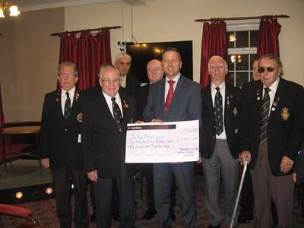



President, Brian Stonehouse, presents a cheque for £1,250.80 to the Hebburn and Jarrow branch of The Royal British Legion.

The second beneficiary of our fundraising efforts this year was, as usual, the Insurance Charities. The charity for the UK and Irish insurance industry, providing support for current and former insurance employees and their dependants since 1902. They give over £1 million of help each year to insurance people in need. A cheque for £1,250.80 was sent to them following our Annual Dinner.

[](https://www.theinsurancecharities.org.uk/)

Dave Robson Cert CII

Charities Representative

# Personal Finance Society Representative’s Report

Looking back over the last year as representative of the Personnel Finance Society (PFS) on the CII council for Newcastle, I feel we have been able to continue to create a far stronger link between the general insurance side and the financial services side of our industry. In the coming year and subject to final voting and confirmation it will be great to see that a Financial Services adviser will succeed our current president in the role. I would also like to go on record to thank Katie Thorne the president elect for her work within the PFS committee in the Tyne / Tees region and wish her all the very best for the coming year.

I also feel it is appropriate at this point to make public record of my thanks on behalf of the PFS Tyne Tees region and its advisers to the CII council in Newcastle for their financial support. This support which was warmly received allowed us to hold a full day training for advisers looking to take the CII’s RO8 pension update exam. I know from speaking with members that this support was greatly appreciated and on the back of this we hope to run further courses over the coming year.

During the last year we have seen record numbers attending the PFS quarterly meetings at Ramside Hall Hotel in Durham. A goal for the coming year is to try and develop further meetings and events in which both PFS and CII members can be jointly involved.

On the PFS side we have seen some changes in our committee and it is great to see some new faces. Rachel Bruce and Helen Johnson have come onto the committee taking on the roles of Membership Officer and Education Secretary respectively and I am sure both will contribute towards greater integration between the two sides.

On final note I wish to state that I hope to continue to develop the strong link we have and hope that we can also continue to educate all members within the Newcastle / Tyne Tees region as to the benefits of being members of the Chartered Insurance Institute and the Personal Finance Society

David Gunning Cert CII (MP & ER), Dip PFS

PFS Representative

# Council Proposed Deputy President 2016-2017

I have been working within the Insurance sector for the past 29 years starting my career with NFU Mutual in 1987 advising and selling insurance solutions to the farming community where I belonged. My parents and their families both farmed in the North East and North Yorkshire and I felt that my agricultural background would give me a head start with the NFU Mutual and although I had not considered a career in insurance found I really enjoyed the technical aspect. In 2003 I decided to widen my horizons and left NFU Mutual to join Ecclesiastical’s Underwriting Department in Newcastle as a Development Underwriter and for the past 7 years I have enjoyed working as an on-site Underwriter in the North East for Arista Insurance Ltd in an underwriting/sales role

Following my return to work after having my family I decided to start my professional qualifications as I felt that although I was continuing to learn through my day to day role I wanted to fulfil my potential as an insurance professional and provide the best advice and service that I possibly could. Balancing a full time job with 3 young children gave me limited time to study, however I was determined to complete my ACII and used whatever free time I had to devote to my studies and completed my ACII in February 2011 at which time I was also awarded Chartered Status.

Three years ago I decided to join the Council of the Insurance Institute of Newcastle to give something back to the organisation that had supported me through my professional development.

I volunteered to take the role of Deputy Dinner Secretary which I have thoroughly enjoyed and will continue to do so. I have also had an insight into the work that Council does, particularly in terms of the support Council gives to the learning and development of individuals and assistance with their examinations and I am very keen assist with this going forward. Becoming Deputy President will also give me the opportunity to become involved with the CII nationally and I am interested in understanding the wider aspects of the CII in the coming year

I am really looking forward to supporting Katy Thorne achieve her goals as President and am sure that 2016 will be another successful year for the Insurance Institute of Newcastle Upon Tyne and that it will continue to successfully evolve for the benefit of our members

Julie Hyde ACII, Chartered Insurer

# Treasurer’s Report

The function of the Treasurer is to:

* Ensure the financial integrity of the local institute, and immediately report any concerns to the President and to Council
* Report to Council on the financial standing of the local institute at each Council meeting, or arrange for an alternate to do so if necessary
* Ensure that financial transactions are appropriate and financial affairs are conducted within the constitution
* Report to Council on the results of local institute events and investments and make recommendations as to any future actions that should be taken
* Arrange for an annual independent audit of the local institute’s accounts, and annual financial statements
* To present to the AGM a set of audited financial statements, and in the event of concern of a material malpractice or that the local institute is likely to become insolvent, report the concern to the CII
* Issue cheques timely upon production of authorised payment requests.

Enclosed is a copy of the local institute accounts for the calendar year ending 31 December 2015.

In summary, we remain in a healthy financial position despite making a trading loss of £5,608 on trading revenue of last year £31,740. The previous year (2014) we made a trading profit of £2,657 on trading revenue of £40,919.

There are three reasons for the trading loss:

1. We continue to receive a central grant from CII London, calculated at a rate of 12% of the aggregate fees paid to the CII by our local institute members. But in 2015 the amount of our grant that we actually received from CII London was cut by £3,684 from £16,257 to £12,573. This cut was made by CCI London to reflect the fact that we have reserves of greater than one year’s income. Our grant will continue to be cut each year until we use up enough reserves to take them below our annual income. Page 3 shows the Balance Sheet and our current reserves (Net Assets) stand at £26,976.
2. Our Training & Education efforts were greater than last year. Our costs were £10,992 in 2015 compared with £8,217 the previous year in 2014.
3. The annual dinner made a loss of £977. The number of attendees was down on previous years because several insurers and loss adjusters chose on this occasion not to host a table.

We had 274 attendees compared with 332 in the previous year (2014), a reduction of 56 people, nearly 20%. Numbers around 330 had been the norm for the past few years. With a ticket price of £70 a head it means our income was down by £4,000 this year. We are charged £33.30 per attendee by the venue, the Civic Centre. Our loss of net income from around 60 less attendees was therefore £2,130. With just 26 more attendees the dinner would have broken even.

We make Charitable Donations from money raised in the raffle at our annual dinner. The money raised this year was less than previous years because of the reduced number of attendees at the dinner. Nevertheless, we raised £2,502. We donated 50% to Insurance Charities at CII London and 50% to the President’s chosen charity the Royal British Legion.

Professional Examination Prizes totalled £1,500. This is £350 less than last year because we did not have a suitable individual to whom we could award the Young Achiever prize.

Sports & Social activities cost £1,466. The annual 5-a-side football competition cost £601, the subsidised annual quiz cost £620 (entry fees received totalled £355 and expenses totalled £975) and the first meeting of the newly created Young Professionals Group cost £244.

The annual loss £5,608 is paid from the reserves (Accumulated Funds, Balance at start of period) on page 3.

Current Liabilities of £540 are expenses that were incurred at 31 December 2015 year-end but not paid by that date. The amount is the external Accountants annual fee of £540.

Willard Wright BA (Hons), ACII, Chartered Insurance Broker

Treasurer

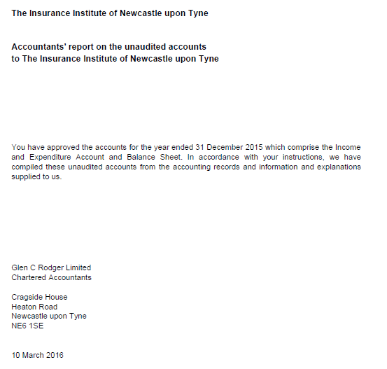

# Financial Statements for the year ended 31st December 2016

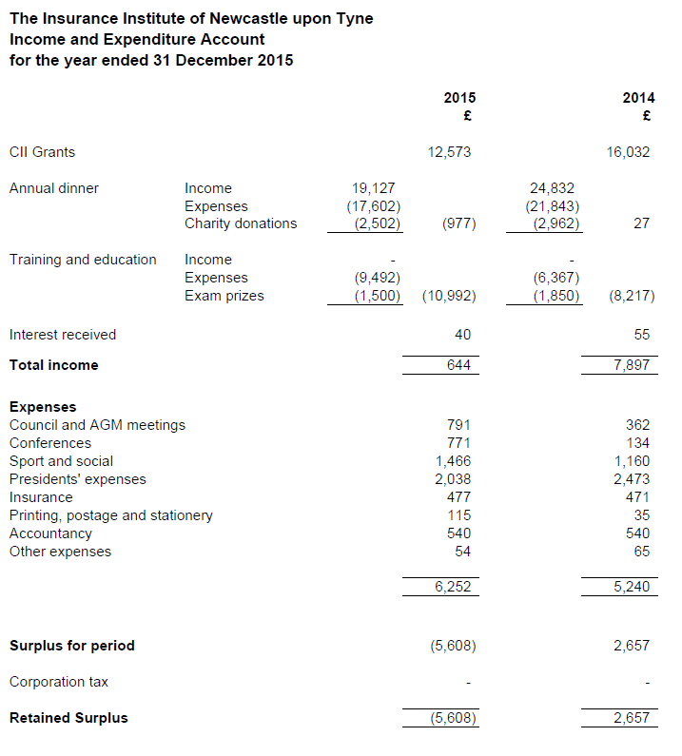

## Balance Sheet

